Data Analysis

Download this zip package ( https://doms.csu.edu.au/csu/file/8ecc7393-0664-44fc-8288- 8a5a29de687b/1/ITC558_202030_A3_dataset.zip ) which contains three dataset files: ‘life.csv’, ‘bmi_men.csv’ and ‘bmi_women.csv’. First file contains data about average life expectancy (in years) for most countries worldwide. Other two files contain data about men and women average Body Mass Index (BMI) for the same set of countries. These are plain text files with all data separated by commas. You can also open the files in a spreadsheet application to better understand their contents. All three files have a similar structure — first row contains the year headers and first column contains the country names. There is data about 186 countries for a period of 1980 to 2008.

Your program should perform the following steps.

1. Read all the data from files and save into a 2D list and two dictionaries.

The life expectancy data should be stored in the form of two dimensional list where the outer list has 186 elements. Each inner list contains data for specific countries.

The BMI data from both files should be stored in two dictionaries which map country names to a list of data values. Both dictionaries will contain 186 keys, with each key associated with a list of 29 values (BMI data from 1980 to 2008).

Following diagram illustrates the required data structures. Note that all numbers have been converted from string to float data types.

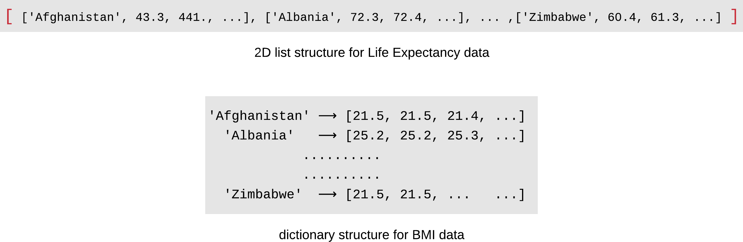

You should use these collections for the next five steps — do not read the files again.

1. Some users may be interested in gender neutral BMI data. For this purpose, create another Python dictionary bmi_all of the same structure and size as bmi_men (or bmi_women) and populate it with worldwide gender-average BMI values. For example bmi_all for Zimbabwe in 2008 would be 23.3.
2. Use the bmi_all dictionary from step 2 to calculate worldwide statistics (min, max

and median (https://en.wikipedia.org/wiki/Median#Finite_data_set_of_numbers )) for a user- selected year. See example in the sample-run below. Median value should be displayed with a precision of 3 decimal places.

1. Compare the latest 5-year BMI data for men against women for the three most populous countries in the world (China, India, United States). First work out the 2004 to 2008 men’s BMI average for these countries. Repeat the same for women’s BMI. Then display the men and women BMI values and the percentage difference ( https://[www.mathsisfun.com/percentage-difference.html](http://www.mathsisfun.com/percentage-difference.html) ) between the two. Display all values with 2 decimal places precision.
2. Plot life expectancy trend of a user selected country. Your program will prompt the user for a country name (case insensitive) and then create a line chart showing life expectancy variation over the years. Sample run below shows an example.
3. To explore the correlation between BMI and life expectancy, plot worldwide average values of the two on the same chart. For this purpose, your program will create two lists of 29 elements each to store worldwide average BMI and life expectancy data for each year. Refer to sample run for an example.

[Disclaimer: Correlation does not imply causation (https://[www.tylervigen.com/spurious-](http://www.tylervigen.com/spurious-) correlations ).]

For plotting charts in step 5 and 6, use the matplotlib library. Consult the textbook section 7-8 to learn how to draw simple charts. The chart for step 6 is rather complex because it contains two y-axis. For this part, please review and adapt the sample code below.

import matplotlib.pyplot as plt

x_data = [20, 21, 22, 23, 24]

y1_data = [1, 3, 5, 8, 10]

y2_data = [100, 150, 190, 180, 115]

fig = plt.figure()

ax1 = fig.add_subplot() ax1.set_xlabel('X data') ax1.plot(x_data, y1_data,'b*-')

ax1.tick_params(axis='y', labelcolor='b') ax1.set_ylabel('Y1 data', color='b')

ax2 = ax1.twinx() # create a second axes that shares the same x-axis ax2.plot(x_data, y2_data, 'ro-')

ax2.tick_params(axis='y', labelcolor='r') ax2.set_ylabel('Y2 data', color='r')

plt.show()

**Important Note:** Other than matplotlib, you can NOT use any library module or third party module in this assessment.

Your program should be able handle following invalid inputs or error situations.

* + Any of the three dataset files do not exist or can’t be read.
  + Non-numeric or out of range year value provided by user.
  + Incorrect country name provided by user.

A sample run of the program is given below to clearly demonstrate all the requirements.

A simple data analysis program

--- Step 1 ---

All dataset has been read into memory.

--- Step 2 ---

Gender-average BMI data stored in a new dictionary.

--- Step 3 ---

Select a year to find statistics (1980 to 2008): **garbage**

<error> That is an invalid year.

Select a year to find statistics (1980 to 2008): **1990**

In 1990, countries with minimum and maximum BMI values were 'Vietnam' and Median BMI value in 1990 was 24.450

--- Step 4 ---

Men vs women BMI in highest population countries:

*** China *** Men: 22.82

Women: 22.86

Percent difference: 0.18%

*** India *** Men: 20.92

Women: 21.22

Percent difference: 1.42%

*** United States *** Men: 28.30

Women: 28.18

Percent difference: 0.42%

--- Step 5 ---

Enter the country to visualize life expectancy data: **jupiter**

<error> 'jupiter' is not a valid country.

Enter the country to visualize life expectancy data: **sRi laNka**

Plot for 'Sri Lanka' opens in a new window.

--- Step 6 ---

Correlation plot opens in a new window.

Goodbye.